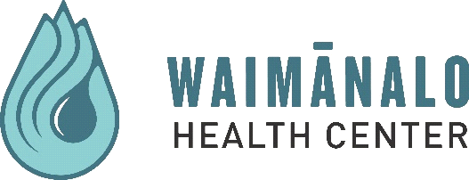

REQUEST TO CONDUCT RESEARCH FORM

Date: | Funding Period: | Project Period:
Lead Agency: | Letter of Intent Deadline: | Proposal Deadline:
Contact Person: | Proposed Period of Time at WHC:
Address: | Funding Source: | Total Funding Amount Available:
Phone#: | Funding Available to WHC: | Cost to WHC of Non-Funded Items:
Email: | Amount/Type of In-Kind Contributions being sought from WHC:
PROJECT TITLE:

PROPOSED ACTIVITY/CONCEPT:
Rationale:

Study Design:

ETHICAL ISSUES (Describe the following):

Patient Safeguards (Specific components of the study methodology and tools designed to protect participants. Ex: Will participants experience more risks than standard of care or any physical ailments as a result of being in the study? Will participation result in undesired changes in thought processes and/or emotion? Are participants exposed to increased costs by participating? If the research project is related to topics requiring mandatory reporting in the State of Hawaii, explain how this will be addressed with participants. How will data be stored and protected?):

Informed Consent Process:

Adherence to HIPAA Regulations and Data Use/Protection Standards:

PARTICIPANTS BENEFIT FROM RESEARCH:

COMMUNITY BENEFITS FROM RESEARCH:

COLLABORATIVE ARRANGEMENTS (From conception, proposal development, data collection, analysis, to dissemination)
WHC Staffing and Their Role:

External Staffing Role:

How Does Activity fit into Goals of WHC:

How Will the Community be Involved in Planning and/or Implementation:

PLAN FOR DISSEMINATION OF FINDINGS TO WHC and COMMUNITY:

Draft Budget to WHC Attached: Yes No If No, explain:

OWNERSHIP OF DATA: Data requested through a limited data set is owned by Waimanalo Health Center. Waimanalo Health Center also maintains co-ownership of data (outside of a limited data set) collected from patients and/or staff while conducting research at WHC.
All research request proposed to be conducted at WHC must be approved by the Research Committee before proceeding. The Research Committee meets every other month (odd months) on the second Wednesday of the month to review request. All research approved by the Research Committee and approved for funding by the funding source must be reviewed and approved by an IRB before implementation. Thank you for submitting your request we look forward to establishing a beneficial and ongoing relationship.

FOR Waimanalo Health Center Use Only:

Research Proposal Reviewed: |  | Approved |  | Approved with Revisions |  | Not Approved
Recommendations for Revisions:

